BRAINWARE UNIVERSITY
STUDENT RESULT AND CONTACT MANAGEMENT SYSTEM (WEEK 8)

1. Basic Information
Programs Covered: | Program 1: Student Result Management System  Program 2: Mobile Contact and Call Management System
Name(s) of Student(s): | Soumyadwip Das (BWU/BTS/25/169)  Ankita Paul (BWU/BTS/25/180)  Sonia Naskar (BWU/BTS/25/195)  Joyeta Mondal (BWU/BTS/25/214)  Sayantan Bharati (BWU/BTS/25/503)
Programme & Semester: | B.Tech CSE & 3rd Semester
Course Name & Code: | Python Programming Lab (BES09013)
Name of the Guide/Supervisor: | MR. PRANAB GHARAI & MR. INDRANIL DAS
Project Date | 04/09/2026



2. Introduction and Background
Week 8 covers two menu-driven, terminal-based record-management tools: a Student Result Management System for maintaining student records, subject marks, and grades, and a Mobile Contact and Call Management System for maintaining a contact book and a call log. Both programs keep core data-handling logic in dedicated functions separate from the input/output (menu) handling, and both use in-memory Python dictionaries as their data store.

3. Objectives of the Project (Week 8)
Program 1 - Student Result Management System
- Add and store student records (roll, name, section, course, year)
- Record subject-wise marks for each student
- Calculate percentage and grade from stored marks
- Display a full formatted result report for a student
Program 2 - Mobile Contact and Call Management System
- Add, view, search, update, and delete contacts
- Resolve a call target by contact name or phone number
- Log outgoing calls with a timestamp
- Display a formatted call history

4. Problem Statement / Driving Question
Program 1: How can student records, subject marks, and grades be tracked accurately for quick lookup and reporting?
Program 2: How can a contact book and call log be managed reliably, supporting lookups by either name or phone number?

5. Methodology (Week 8 Activities)
Program 1 - Student Result Management System
- Modelled each student as a dictionary entry keyed by roll number, holding a nested results dictionary
- Built core functions (add_student_data, add_marks_data, calculate_merit) with no I/O
- Built a get_grade / get_percentage pair to derive grade bands from average marks
- Built UI handler functions in a menu loop that call the core functions and print boxed results
- Tested add-student, add-marks, calculate-grade, and display-report flows
Program 2 - Mobile Contact and Call Management System
- Modelled contacts as a dictionary keyed by name, and call history as a list of records
- Built core functions (add_contact_data, search_contacts, update_contact_data, delete_contact_data)
- Built resolve_call_target to accept either a contact name or a raw phone number
- Built UI handlers for adding, viewing, searching, updating, deleting contacts, and making calls
- Tested add, search, update, call, and call-history flows

6. Expected Outcomes / Deliverables (Week 8)
- Working Student Result Management System with grade calculation
- Working Mobile Contact and Call Management System with call logging
- Clear separation of core logic and UI code in both programs
- Accurate percentage and grade computation from subject marks
- Reliable contact lookup by name or phone number

7. Core Logic
Program 1 - Student Result Management System
def add_student_data(roll, name, section, course, year):
if roll in ROLLS:
return False
ROLLS.append(roll)
all_students[roll] = {"name": name, "section": section,
"course": course, "year": year, "results": {}}
return True

def add_marks_data(roll, subject, marks):
if roll not in ROLLS: return False
if not 0 <= marks <= 100: return False
all_students[roll]["results"][subject] = marks
return True

def get_grade(roll):
subjects = all_students[roll]['results']
if not subjects: return "N/A"
percentage = sum(subjects.values()) / len(subjects)
if percentage >= 90: return "A"
elif percentage >= 75: return "B"
elif percentage >= 50: return "C"
else: return "F"

def calculate_merit(roll):
if roll not in ROLLS or not all_students[roll]['results']:
return None
percentage = get_percentage(roll)
grade = get_grade(roll)
all_students[roll]["merit"] = {"percentage": percentage, "grade": grade}
return percentage, grade

Program 2 - Mobile Contact and Call Management System
def add_contact_data(name, phone, email):
if name in contacts:
return False
contacts[name] = {'phone': phone, 'email': email}
return True

def search_contacts(term):
term = term.lower()
matches = {}
for name, details in contacts.items():
if term in name.lower() or term in details['phone']:
matches[name] = details
return matches

def resolve_call_target(target):
if target.isdigit():
for name, details in contacts.items():
if details['phone'] == target:
return name, target
return target, target
if target in contacts:
return target, contacts[target]['phone']
return None, None

def log_call(target, number):
call_records.append({'type': 'outgoing', 'target': target,
'number': number, 'time': datetime.datetime.now()})

8. Output Screenshot
Program 1 - Student Result Management System
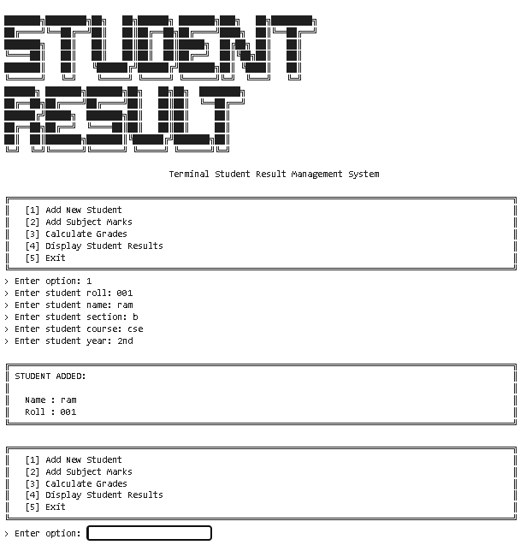
Program 2 - Mobile Contact and Call Management System
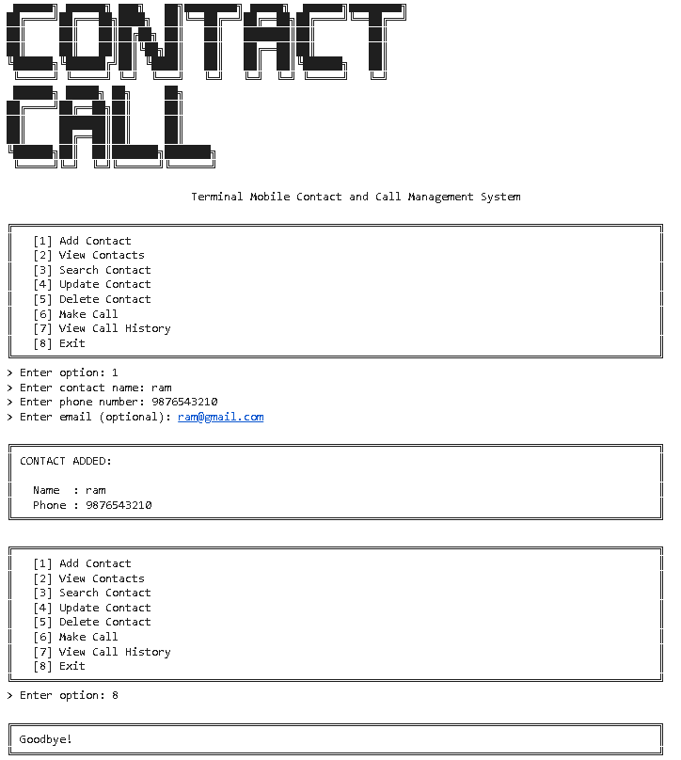

9. Tools & Technologies Used
Tool / Technology | Purpose
Python 3.x | Core language for both console systems
Python Dictionaries | In-memory storage for students, marks, contacts, and call records
Core/UI Separation | Business logic functions kept separate from input/print handlers
Helper Functions | Shared grade-calculation and call-target-resolution helpers
String Formatting (f-strings) | Aligned tabular display of contacts and call history

10. References
- Python Official Documentation: https://docs.python.org/3/
- Python Dictionaries Guide: https://docs.python.org/3/tutorial/datastructures.html
- Brainware University – Python Course Guidelines

11. Signatures
Signature of Student(s): Date of Submission:

Signature of Guide/Supervisor:

